DSCB 225, 2026
Image Analysis Problem Set

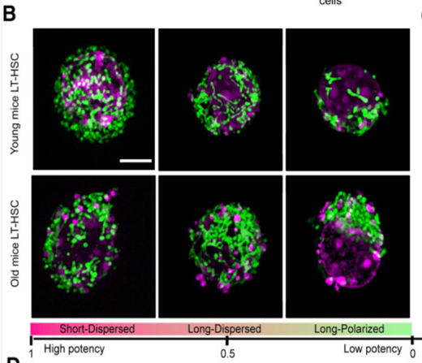
The concept and data for this problem set are inspired by a real study¹ that used super-resolution microscopy to study how the morphology and protein composition of mitochondria in HSCs change with age. This figure shows different mitochondrial morphologies. They found that HSCs with “Short-Dispersed” mitochondria are most likely to differentiate whereas those with “Long Polarized” are least likely to differentiate. I thought it would be interesting to use quantitative imaging to determine if mitochondrial mass in HSCs changes with age so I used ChatGPT to create an artificial set of images for this problem set.

Download the images here: https://ucsf.box.com/s/4oc3uhoy514ppx5369z7r0mnhhkosbty

Imagine these are HSCs derived from young or old mice imaged with brightfield in one channel and MitoTracker dye in another channel. MitoTracker stains all mitochondria evenly, regardless of health or activity levels. 30 images per condition were acquired from each of three replicates, as described in the ExperimentalDesign.csv file. In this problem set, your goal is to analyze the images in this dataset to test whether the young and old groups differ in mitochondrial area and MitoTracker intensity.

Put the downloaded images in a folder in the Images folder of your repository, like this (note the capitalization, etc.):
../Images/HSC_images/Young
../Images/HSC_images/Old

Each image is a 2-channel TIFF with shape (2, Y, X):
Channel 0: mitochondrial signal
Channel 1: cell / brightfield signal

Your tasks
1-2. Import libraries and load the images for both conditions into Python using the code provided.
3. Inspect the shape and data type of one image.
4. Display both channels from one sample image.
5. Plot a histogram of the mitochondrial channel.
6. Segment the cell and mitochondria in one sample image
7. Use this code to write some helper functions that you can use in a for loop to segment all the images
For each image, measure:
- cell_area
- mito_area
- percent_mito = mito_area / cell_area
- mito_mean_masked
8. Put the measurements into a pandas DataFrame.
9. Save the DataFrame as “HSC_results.csv” in your Results folder
10. Read both HSC_results.csv and ExperimentalDesign.csv into an R Notebook
11. Select just the replicate and file columns from the ExperimentalDesign DataFrame and merge it with the HSC dataframe
12. Group the data by replicate and condition and create a summary DataFrame that contains the mean MitoTracker intensity values and mean percent mitochondria values.
13. Perform T tests on both sets of means.
14. Produce ggplot boxplots with points overlaid for both parameters.
15. Answer the questions at the end.

Submit your work as a two files: a completed jupyter notebook and a completed R notebook

¹Shi, Z., Zhang, X., Yang, H., Zheng, X., Niu, M., Zhang, Y., Yuan, P., Wei, W., Huang, G., Fang, R., et al. (2025). Super-resolution imaging informed scRNA sequencing analysis reveals the critical role of GDF15 in rejuvenating aged hematopoietic stem cells. Blood Sci. 7, e00236.

